Checklist of Common Mistakes Made in Formatting a Thesis or Dissertation

This checklist is provided to minimize the number of times that your dissertation or thesis format will need to be re-checked by the graduate school. Although this checklist does not include all formatting rules, it will help you to avoid the most common mistakes. Use this checklist with the template file “LaTech Thesis-Dissertation Template.dotx.”

Page Layout

Side Margins: The left margin is 1.5 inches. The right margin is 1.0 inch. No written or graphical information is outside of these margins. (Figure 1)

Top Margins: Each new major section (see Major Section Headings) begins 2 inches from the top of the page (Figure 2). Subsequent pages have a 1 inch top margin (Figure 3).

Bottom Margins: The bottom margin is 1 inch (Figure 4).

Page Numbers: Page numbers are in 12 point font. They are centered at the bottom of the page for the first page in a major section, and are on the right of the top of the page for subsequent pages.

Major Section Headings

Major sections include: Abstract, Dedication, Acknowledgements, Preface, Table of Contents, List of Tables, List of Figures, List of Abbreviations, other lists, Chapters, Appendices, and References (Bibliography). Some programs may require other major sections.

Font Size for Major Headings: The Font Size is 14 point for all major headings (Figure 2).

Font: The font type for major headings is the same as the rest of the document. (E.g., if the text of the narrative is Times New Roman, the major headings are in Times New Roman).

Top Margins: The heading for a major section begins 2 inches from the top of the page (Figure 2).

Text of the Narrative

Requirements in this section refer to most of the paragraphs in your narrative. These requirements will generally be handled with the “Normal” paragraph style that you define in Microsoft Word.

Font Size for Text: The Font Size is 12 point for the Text, Footnotes, and Page Numbers.

Font: Approved font styles are used, which are Times Roman, Times New Roman, Courier, or Courier New. (The Appendix Material may be in another font and size.)

Font Style: The font style for normal paragraphs is regular. Italic font is used for foreign words. Bold, Outlined, or Shadowed Text are not used in the narrative.

Line Spacing: Text of the narrative is double-spaced (Figure 5).

Paragraph Form – Left Side: Paragraphs are aligned on the left (), with the first line of each new paragraph indented. Indentation is consistent from paragraph to paragraph, no less than 0.3 inches and no more than 0.5 inches.

Paragraph Form – Right Side: Paragraphs are not right-justified. Do not use the  paragraph option.

Widows and Orphan Control is Used: A widow occurs when the last line of a paragraph appears at the top of a page. An orphan occurs when the first line of a paragraph appears at the bottom of a page. In both cases, you must alter the page break so that at least two lines appear together. In MS Word, your “Normal” paragraph style should have “Widow/Orphan control” and “Keep with Next” checked, and all of your header styles should have “Keep with Next” checked (Figure 6).

Preliminary Pages and Major Sections

Title Page: The first page of the document is a title page.

The title page is not marked with a number, but included in the page count as Page i.

No text on the title page is italicized.

The title page includes:

Title: Type in all-capital letters, double-spaced, and in inverted pyramid form (Figure 7).

Author Name: Use the official name by which you are known to the University (Figure 8).

Current Degrees: Do not include the degree for which the thesis or dissertation was written. (I.e. a student who is writing a dissertation might list B.S. and M.S., but not Ph.D). See Figure 8.

Degree Identifier: The statement “A Thesis Presented in Partial Fulfillment of the Requirements of the Degree of Master of Science” or “A Dissertation Presented in Partial Fulfillment of the Requirements of the Degree of Doctor of Philosophy,” as appropriate (Figure 9).

University and College Identifier: The statement “COLLEGE OF <x>, LOUISIANA TECH UNIVERSITY,” in all-capital letters, where <x> is replaced by your college name (Figure 10).

The Date: Use the last month of the term in which the degree will be granted (last month of your graduation quarter), followed by the year. For example, if your degree will be granted in Fall of 2010, the date will be “November 2018” (Figure 10).

Signature Page: Use GS form 13. The page is not marked with a number, but is included in the page count as Page ii.

Abstract: The third page of the document is the beginning of the Abstract and is numbered with the Roman numeral iii at the bottom center.

Abstract Continuation: If the Abstract is more than one page long, continued pages are numbered with Roman numerals at the top right of the page.

Approval for Scholarly Dissemination: Use GS form 14. The page is not marked with a number, but included in the page count.

Dedication: A major section. Start two inches from the top of the page and number in Roman numerals.

Table of Contents

The section begins with the title “TABLE OF CONTENTS” two inches from the top of the page.

The Table of Contents does not include an entry for the Table of Contents.

The heading “TABLE OF CONTENTS” is in the same font as chapter headings.

Section numbers and headings are not in italics or bold.

Entries are separated by double-spacing.

All numbered sections are included, with the page numbers on which they start.

List of Figures

Headed with “LIST OF FIGURES,” beginning two inches from the top of the page.

Includes figure numbers, figure captions, and page numbers.

If a caption spans more than one line, single space the caption, but double-space between figure captions. (Figure 11)

If a caption spans more than one line, none of the caption appears above the page number. (Figure 11)

List of Tables

Headed with “LIST OF TABLES,” beginning two inches from the top of the page.

Includes table numbers, table captions, and page numbers.

If a caption spans more than one line, single space the caption, but double-space between table captions.

If a caption spans more than one line, none of the caption appears above the page number.

Chapter 1

Begins on Page 1, numbered at the bottom center in Arabic numerals.

The header begins two inches from the top of the page.

Sequential pages are numbered at the top right of the page in Arabic numerals.

Subsequent Chapters

First page is numbered at the bottom center in Arabic numerals.

The header begins two inches from the top of the page.

Sequential pages are numbered at the top right of the page in Arabic numerals.

Headings (Other than Major Section Headings)

All section headings are in 12 point font.

Heading numbers are never italicized.

Section headings are left-justified (except for the major subheadings, one level below major section headings, which may be centered).

A triple-space appears before the beginning of a major subheading (Figure 12).

A double-space appears after each major subheading. (Figure 12).

Appendices

Each appendix is preceded by a single title page with only the appendix identifier and title. For example, “APPENDIX A: TEMPERATURE MEASUREMENTS FROM JUNE 2010.”

Appendices are labeled with capital letters, such as “APPENDIX A,” “APPENDIX B,” and “APPENDIX C.”

Appendix titles are treated in the same way as chapter titles with respect to spacing and font.

Table and figure numbering begins with the appendix label, as in “Table A1” for Appendix A and “Table B1” for Appendix B.

The first page of each appendix is numbered at the bottom center in Arabic numerals.

The header begins two inches from the top of the page.

Sequential pages are numbered at the top right of the page in Arabic numerals.

References or Bibliography Entries (Figure 13)

The title “REFERENCES” or “BIBLIOGRAPHY” appears at the top of the first page, beginning two inches from the top of the page.

Entries are single-spaced.

Separation between entries is double-spaced.

Formatting conforms to standards for your program of study.

Formatting of all bibliographical entries is consistent.

All listed entries are cited within the dissertation or thesis body.

References for all citations within the dissertation or thesis body are provided.

Figures

Each figure caption appears below the figure.

Each figure is referenced within the narrative of the document.

Each figure appears after the first reference to it within the narrative.

Each caption includes the word “Figure,” followed by the figure number (Figure 14).

Figure captions are single-spaced

Single-line captions are centered. Multiple-line captions are left-justified.

A consistent style is used for all figures.

A triple-spaced line (24 point vertical space) appears between the document narrative and the top of the figure (Figure 14).

A double-spaced line (12 point vertical space) appears between the bottom of the figure and the figure caption (Figure 15).

A triple-spaced line (24 points of vertical space) appears between the figure caption and the following text (Figure 16).

Figures do not break across pages.

Tables

Each table caption appears above the table.

Each table is referenced, by table number, within the narrative of the document.

Each table appears after the first reference to it within the narrative.

Each caption includes the word “Table,” followed by the table number.

Table captions are single-spaced

A consistent style is used for all tables.

A triple-spaced line (24 point vertical space) appears between the text and the table caption (Figure 17).

A double-spaced line (12 point vertical space) appears between the caption and the top of the table (Figure 18).

A triple-spaced line (24 points of vertical space) appears between the table and the following text (Figure 19).

Tables that are less than one page long do not break across pages.

Tables that are longer than one page long include a separate table header for each page. (This rule may not apply to all formatting styles).

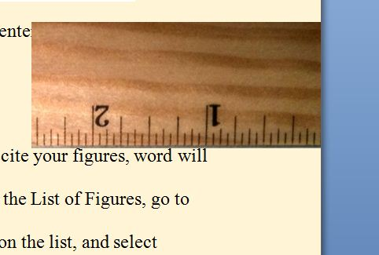
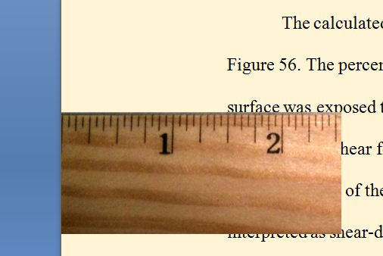

Figure 1: Left and right margins.

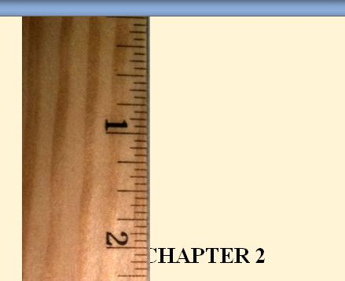

Figure 2: Two inch top margin for Title Page, Abstract, Table of Contents, List of Figures, List of Tables, Chapters, Bibliography and Appendices.



Figure 3: One inch top margin for most pages of the document.

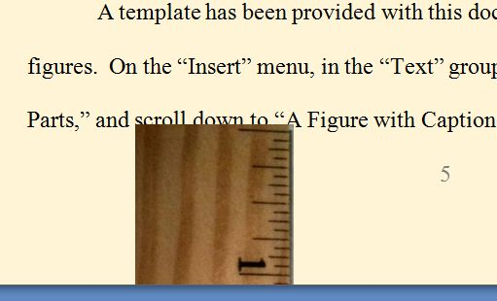

Figure 4: Bottom margin set to one inch. In most cases the pagination and page breaks will lead to bottom margins that are greater than one inch.

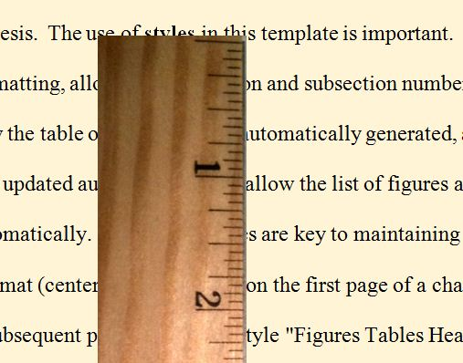

Figure 5: Double-spaced lines.

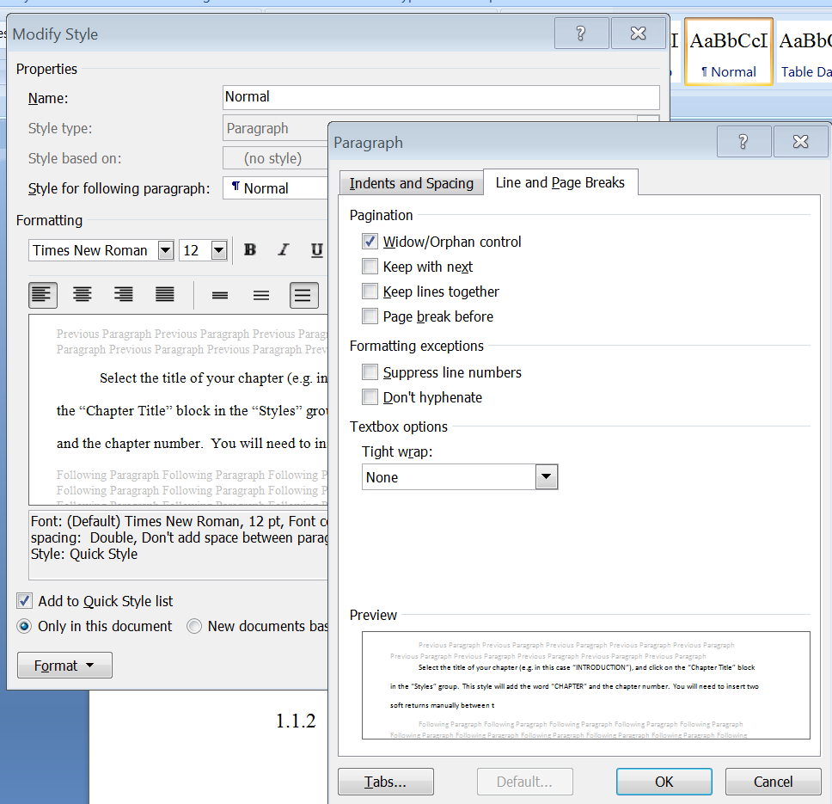

Figure 6: Line and Page Break options for Normal paragraph format.

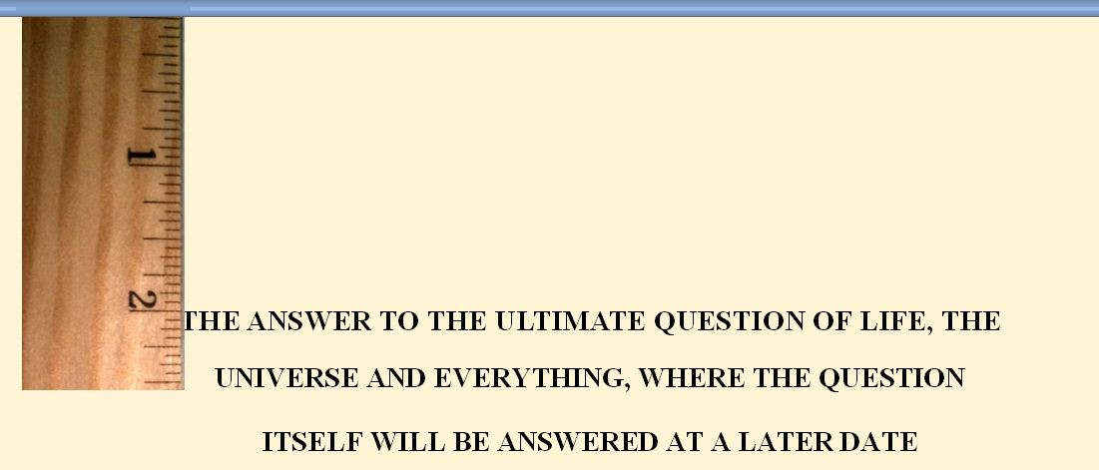

Figure 7: Double-spaced title with all capital letters in inverted pyramid form.

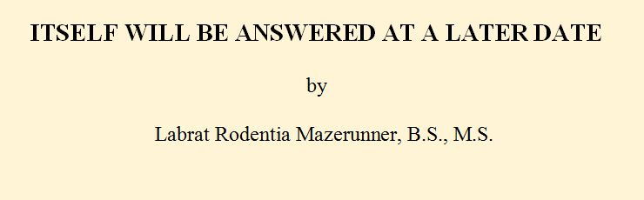

Figure 8: Author name and current degrees.

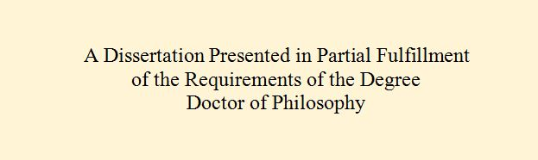

Figure 9: Degree identifier for a dissertation.



Figure 10: College identifier and date for a student in the College of Engineering and Science graduating in fall of 2010.

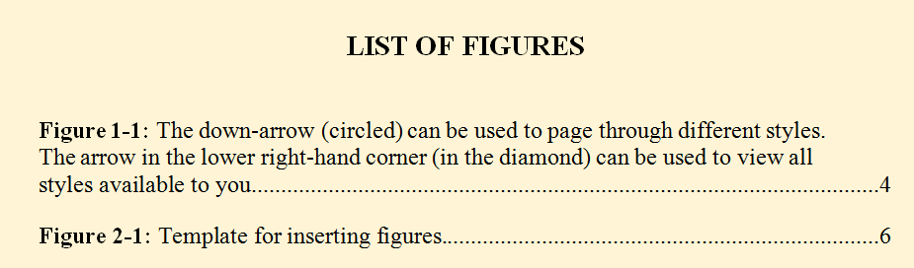

Figure 11: Figure captions in the List of Figures are single spaced, with double-spacing between captions. The figure caption of Figure 1-1 is formatted so that none of its text is directly above the figure number.

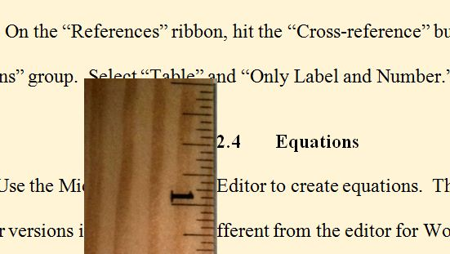

Figure 12: Triple-spacing before a major subsection.

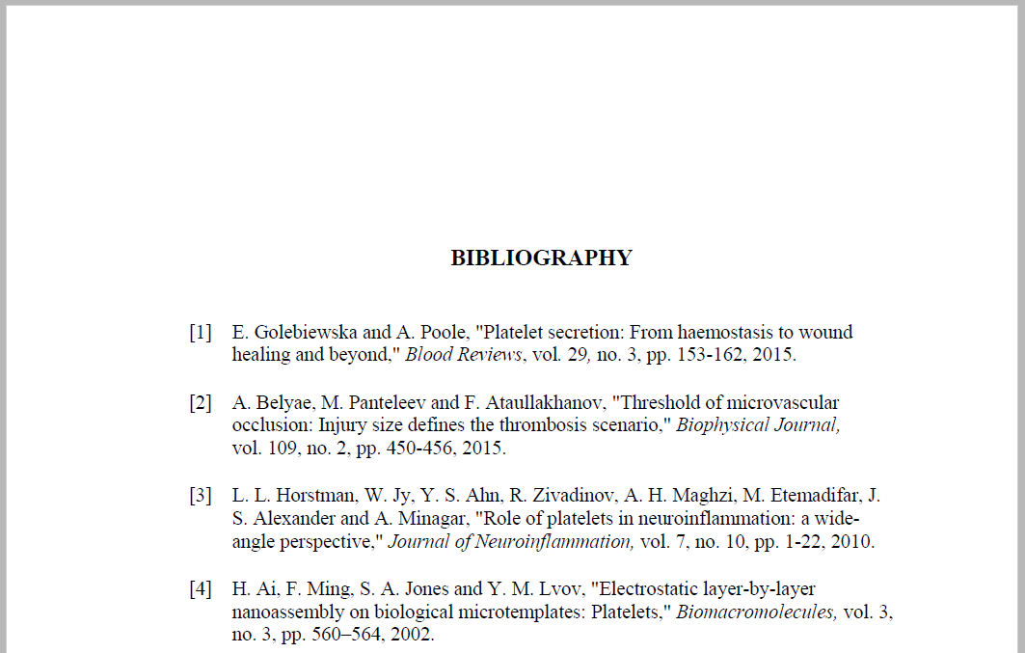

Figure 13: Example bibliography entry. The order must be consistent with standards for your discipline and must be consistent for all entries. Here it is author(s), article title, journal name, volume, number, page(s), year. You cannot simply cut and paste entries from other sources into your bibliography because different sources can have different formats. Pay attention to: 1) The format for authors’ names (here it is initial(s) followed by last name, with periods after the initials and commas separating multiple names). 2) Italics (here, only the journal name is italicized). 3) Capitalization (here, the first word of each article title is capitalized and the remaining words are not, except where the context otherwise requires capitalization as in proper names or after punctuation). (4) Consistent punctuation. 5) Consistent formatting for keywords such as “vol.” “no.”, or “pp.” (These keywords may or may not be present, depending on the references style used. When present they must be either capitalized throughout or not capitalized throughout).

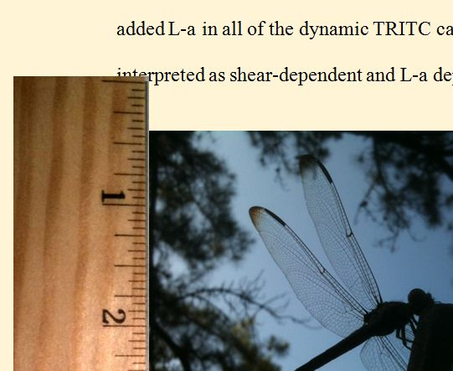

Figure 14: Triple-spacing before a figure.

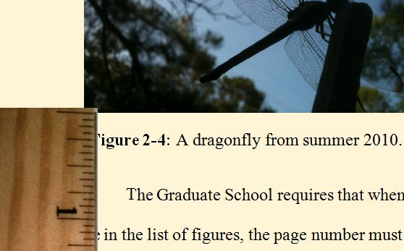

Figure 15: Double-spacing between a figure and caption.

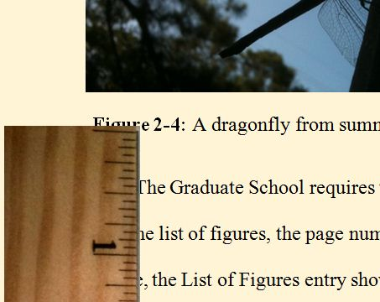

Figure 16: Triple-spacing between a figure caption and text.

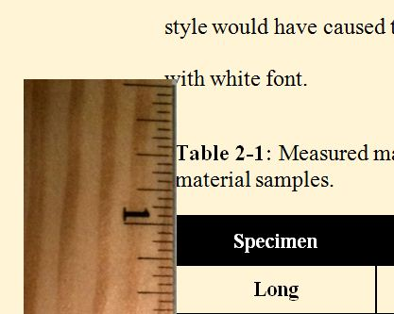

Figure 17: Triple-spacing between text and table caption.

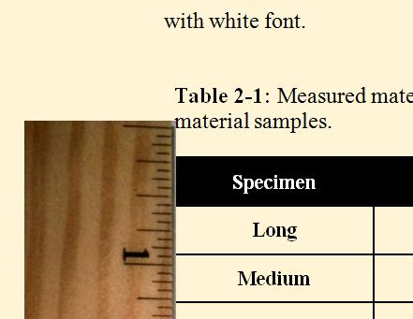

Figure 18: Double-spacing between a table caption and table.

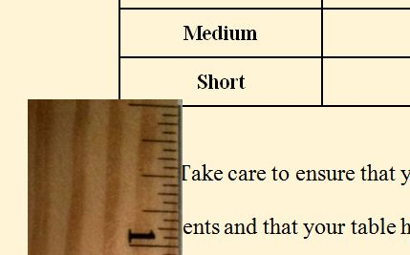

Figure 19: Triple-spacing between a table and the following text.

