Dissertation or thesis title line one
document title line two
title line three
by
Author Name and Current Degrees

A Thesis Presented in Partial Fulfillment
of the Requirements of the Degree
Master of Science

COLLEGE OF Choose an item.
LOUISIANA TECH UNIVERSITY

Choose an item. Click here to enter text.

LOUISIANA TECH UNIVERSITY

THE GRADUATE SCHOOL

Click here to enter a date.
Date

We hereby recommend that the thesis prepared under our supervision by xxxxxxxxxxxxxxx
Author Name and Current Degrees
entitled | Dissertation Or Thesis Title Line One
Document Title Line Two
line

be accepted in partial fulfillment of the requirements for the Degree of

Master of Science in Click here to enter text.

Supervisor of Thesis Research
Head of Department
Department
DO NOT USE THIS PAGE
Recommendation concurred in:

_____________________________

_____________________________
Advisory Committee
_____________________________

_____________________________

Approved: Approved:

__________________________ ______________________________
Dean of the College Dean of the Graduate School

ABSTRACT
This document serves as both a set of instructions and a template for your dissertation/thesis. The use of styles in this template is important. Styles maintain a consistent formatting, allow chapter, section and subsection numbers to be automatically updated, allow the table of contents to be automatically generated, allow figure and table numbers to be updated automatically, and allow the list of figures and list of tables to be generated automatically. In addition, styles are key to maintaining the correct page numbering format (centered at the bottom on the first page of a chapter and right-justified at the top of subsequent pages). Use the style "Figures Tables Header" for the title of the sections that are not chapters, including the abstract, dedication, list of figures, list of tables, and appendix. Use the style "Chapter Title" for sections that are numbered chapters, such as "Introduction," "Methods," "Results," "Discussion," and "Conclusions." Your paragraphs will be in "Normal" style.
Text in red within this template is "hidden." It is designed to be visible on the computer screen and to disappear on when the document is printed. To ensure that it is visible on the computer screen but not on paper, hit the command button in the upper left hand corner (), go to "Word Options," and then to "Display." Under, "Always show these formatting marks on the screen," check "Hidden Text." Under "Printing Options," uncheck "Print Hidden Text." If hidden text still prints, delete it.
If your Abstract is more than one page long, the continuation page should be numbered at the upper right in Roman numerals.

APPROVAL FOR SCHOLARLY DISSEMINATION
The author grants to the Prescott Memorial Library of Louisiana Tech University the right to reproduce, by appropriate methods, upon request, any or all portions of this Thesis. It is understood that “proper request” consists of the agreement, on the part of the requesting party, that said reproduction is for his personal use and that subsequent reproduction will not occur without written approval of the author of this Thesis. Further, any portions of the Thesis used in books, papers, and other works must be appropriately referenced to this Thesis.
Finally, the author of this Thesis reserves the right to publish freely, in the literature, at any time, any or all portions of this Thesis.

Author _____________________________

Date _____________________________

DEDICATION
This thesis template is dedicated to everyone who has suffered the frustration of fighting with the “enhancements” of word processing software.

TABLE OF CONTENTS

ABSTRACT iii
APPROVAL FOR SCHOLARLY DISSEMINATION v
DEDICATION vi
LIST OF FIGURES x
LIST OF TABLES xi
ACKNOWLEDGMENTS xii
CHAPTER 1 INTRODUCTION 1
1.1 Chapter Title Formatting 1
1.1.1 How to Format the Chapter Title 1
1.1.2 Chapter Title Troubleshooting 1
1.2 Page Numbering 2
1.2.1 How to Obtain Correct Page Numbering 2
1.2.2 Troubleshooting Page Numbering 2
1.3 Use of Major Subheadings 3
1.3.1 Sub-subheading under Major Subheadings 3
Sub-sub-sub-subheading (Sub(5)) 3
Sub-sub-sub-sub-subheading (Sub(6)) 3
Second sub-subheading 3
1.3.2 How to Locate Subheading Styles 4
1.3.3 Adding Chapters 4
CHAPTER 2 BACKGROUND 5
2.1 A Note on Updating the Document 5
2.2 Automated Figure Captions and Figure Numbering 5
2.2.1 Insertion of a Figure with a Caption 6
2.2.2 Basic Method for Referencing a Figure 7
2.2.3 Troubleshooting Figure Captions 8
2.2.4 List of Figures 9
2.3 Automated Tables 10
2.3.1 Creating Tables and Table Captions 10
2.3.2 Table Style 12
2.3.3 References to Tables in the Narrative 13
2.4 Equations 13
2.4.1 A Simple Way to Number Equations 13
2.4.2 How to Cite Equations in the Narrative 14
2.4.3 Troubleshooting Equation Numbers 14
CHAPTER 3 METHODS 16
3.1 Reference Formatting 16
3.2 Reference Formatting and Referencing in Word 16
3.3 References with Date Only 18
3.4 Generating the Bibliography 18
3.5 Additional Bibliographical Styles 18
CHAPTER 4 RESULTS 20
4.1 Subheading One 20
4.2 Subheading Two 20
CHAPTER 5 DISCUSSION 22
CHAPTER 6 CONCLUSIONS AND FUTURE WORK 24
6.1 Conclusions 24
6.2 Future Work 25
APPENDIX A Purpose and format of an appendix 26
A.1 Appendix Subsection 26
A.2 Figures in Appendices 26
A.3 Equations in Appendices 27
APPENDIX B Details about Captions 28
B.1 Figures 28
B.2 Tables 31
B.3 Comments on Equation Numbering in Microsoft Word 32
REFERENCES 33

LIST OF FIGURES
Figure 1-1: The down-arrow (circled) can be used to page through different styles. The arrow in the lower right-hand corner (in the diamond) can be used to view all styles available to you. This caption uses the style “Caption.” 4
Figure 2-1: Template for inserting figures. 6
Figure 2-2: Template for inserting figures. 7
Figure 2-3: Cross-reference dialog box for referencing figures, tables, paragraphs, and other links within the narrative. 8
Figure 2-4: Indentation setting. To ensure that a figure is centered, the tab indent should be changed from ½ inch, as shown here, to 0 inches. 9
Figure 2-5: Incorrectly formatted List of Figures entry. 9
Figure 2-6: List of Figures entry, reformatted to conform to Graduate School requirements. 10
Figure 2-7: Template for inserting tables. 10
Figure 2-8: Symbols group, which can be used to insert equations from the equation gallery. 14
Figure 3-1: If you were a grasshopper, this leaf would look like the edge of the world. 17
Figure A-1: Template for inserting figures into appendices. 26
Figure B-2: A figure for which the caption was created with the “Insert Caption” command. 27

LIST OF TABLES
Table 2-1: This table was generated with the table template and the “Table” icon on the “Insert” ribbon. 12
Table 2-2: This is a minimalist table preferred for a formal document. 12
Table A-1: Template for inserting tables in Appendices. 26

ACKNOWLEDGMENTS
We would like to thank the little people for making this document possible. Furthermore, we would like to thank the Academy, all of our families and friends, Jerry Garcia, and Don Ho of “Instant Happy” fame.
This section is followed by a “section and new page” break (not a section break and a new page break, but a single break that causes a new page and a new section). Use the “Page Layout” ribbon, click next to “Breaks” in the “Page Setup” group, and select “Next Page.”

INTRODUCTION

Chapter Title Formatting

How to Format the Chapter Title
Just before each chapter you need to insert a section break/new page. On the “Page Layout” ribbon, in the “Page Setup” group, click the down-arrow next to “Breaks,” and scroll down to “Next Page.”
Select the title of your chapter (e.g. in this case “INTRODUCTION”), and click on the “Chapter Title” block in the “Styles” group. This style will add the word “CHAPTER” and the chapter number. You will need to insert two soft returns manually between the chapter number and the chapter title. To enter a soft return, simultaneously type the two keys, <Shift>-Enter, instead of just Enter.

Chapter Title Troubleshooting
If the word “CHAPTER” is not correctly positioned two inches below the top of the page, check for the following:
- Make sure that the “section break | new page” appears before the title.
- Make sure that the chapter title is formatted with the “Chapter Title” style.
- Make sure that there is no text preceding the chapter title that is formatted with the “Chapter Title” style. The chapter title should appear immediately after the section/page break, and the text just before the section/page break should be formatted with the “Normal” style. To check for text that is not formatted as “Normal,” go to the end of the last sentence of the previous page, and use the right-arrow of the keyboard to step through character-by-character while watching the “Styles” section of the “Home” ribbon.

Page Numbering
Dissertation/Thesis format requires that the first page of a chapter be numbered at the bottom center of the page and that subsequent pages be numbered at the top right. This numbering is accomplished with the “Different First Page” numbering option and the “Link to Previous” header/footer option.

How to Obtain Correct Page Numbering
The pages should be numbered correctly if you do the following:
- Insert a “Section Break/New Page” just before the title of each major division.
- Use the “Chapter Title” style for the title of each chapter or, equivalently, the “Figures Tables Header” style for the title of other major sections (e.g. “Abstract,” “Dedication,” “List of Figures,” “Appendix”).

Troubleshooting Page Numbering
If problems arise, follow these steps:
- Double-click in the header region of a page to bring up the “Design” ribbon.
- Make sure that the box in the “Options” group labeled “Different First Page” is checked.
- Make sure that the button “Link to Previous” in the Navigation group is highlighted.
- Make sure that a new page section break is inserted just before the chapter name. Any section breaks that are “continuous” must be removed, and only one “section break | new page” must be present.

Use of Major Subheadings
Type the subheading name, highlight it, and click on "Sub1" under "Styles" on the "Home" ribbon. The style will automatically number the subheadings, with the chapter number first and then the subheading number. The font style will also be handled so that it is consistent from one subheading to another. Correct use of these styles allows the Table of Contents to be updated automatically when you right-click on it and scroll down to “update field.”

Sub-subheading under Major Subheadings
To obtain the third level of subheading, highlight the text of the sub-subheading and click on "Sub2" under "Styles" on the "Home" ribbon. The heading will be numbered with the chapter number, the subheading number, and the sub-subheading number. The font style will also be handled so that it is consistent.
Sub-sub-subheading
This template provides six levels of headings, “Chapter Title,” “Sub(2),” “Sub(3),” “Sub(4),” “Sub(5),” and “Sub(6).” The two deepest levels are shown below.

Sub-sub-sub-subheading (Sub(5))

Sub-sub-sub-sub-subheading (Sub(6))

Second sub-subheading
This section reminds you that it makes no sense to have only one subheading of a given level in a section. Do not go crazy with subsections. You should probably never need to have headings deeper than level 4, so if you find that higher levels are frequently needed, you may want to revise the organization of your document. The table of contents in this template is constructed to include only headings up to level 6.

How to Locate Subheading Styles
All of the subheading styles described in this section should be available on the “Home” ribbon in the “styles” group. If you do not see the style you need, click on the down-arrow next to the “Styles” group to scroll through other pages of styles (Figure 1-1).
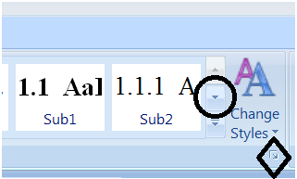
Figure 1-1: The down-arrow (circled) can be used to page through different styles. The arrow in the lower right-hand corner (in the diamond) can be used to view all styles available to you. This caption uses the style “Caption.”
Here is an important note about figures. Figures are embedded in tables. The grid lines of the table containing Figure 1-1 are made visible only to show you how the figure and caption sits in a one-column two-row table. The “caption” style used for the caption incorporates the double space (12 point) below the caption as required. All grid lines should be turned off in the figures in your dissertation. See Fig. 2-1 below.

Adding Chapters
Turn on the paragraph and space marks (click on ¶ in the “Paragraph” menu) to see the Section break at the end of this chapter. If you are adding a new chapter (6 chapters are provided in this template), be sure to insert the Section Break (Layout | Breaks | Section Breaks | Next page).

BACKGROUND

A Note on Updating the Document
Many of the features in this template rely on field codes. For example, the field code that stands for “print the number of the current chapter” is {STYLEREF 1 \s}. If you use the two keys <ctrl><F9> together, Word gives you the two curly brackets into which you can type a field code. You can then place the cursor over the field code you have typed, right-click, and then scroll down to “Update Field” to obtain the text that corresponds to the field code. Another way to update a field code is to highlight it and hit the Update button () on the Quick Access Toolbar. Another option is to highlight it and hit <F9>. To update every field code in your document, type <ctrl>A (select all text in the document) followed by <F9> (update all field codes in the selected text). It is typically necessary to update all fields twice. The first update causes figure captions to be updated. The second update causes the references to those captions to be updated.

Automated Figure Captions and Figure Numbering
Word 2007 and 2010 have a method for automatically numbering figures and for referencing them in the narrative so that the figure numbers are automatically updated. Here, a template is provided that places each figure in a two-row table, with the caption on the bottom row. More extended details of the captioning feature are provided in APPENDIX B, along with an explanation for the use of the table template approach.

Insertion of a Figure with a Caption
A template has been provided with this document to simplify the referencing of figures. On the “Insert” menu, in the “Text” group, click on the arrow below “Quick Parts,” and scroll down to “A Figure with Caption.” The template, labeled here as Figure 2-1, will appear.
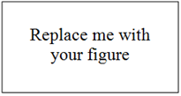
Figure 2-1: Template for inserting figures.
Click on the box labeled “Replace me with your figure,” and paste your figure. Alternately, delete the “Replace me with your figure” bitmap object, and use the “Insert” menu of Word to insert your figure into the table cell. Then modify the caption as needed. You can create a reference to the figure within your narrative as described in Section 2.2.2.
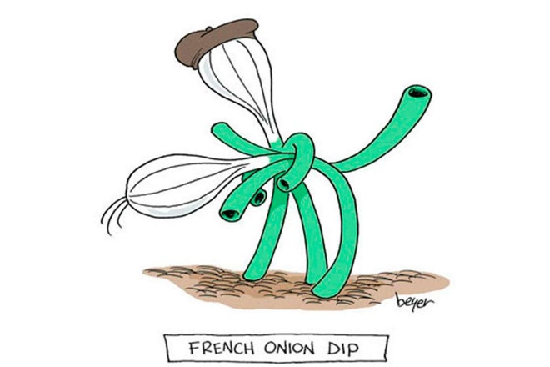
Figure 2-2: Template for inserting figures.

Basic Method for Referencing a Figure
To reference the figure within your narrative, go to the “References” ribbon and click on “Cross-reference” in the “Captions” group. The dialogue box shown in Figure 2-3 will appear. Select the caption that you wish to reference, and select “Only Label and Number.” Also select “Insert as Hyperlink,” so that you (and your committee members) will be able to use <control>-<click> to easily navigate from the figure’s citation to the figure itself. Then hit “OK.” This method links the citation of the figure to the figure number so that references within your narrative will automatically be updated when figure numbers change (for example, when you add a new figure between two pre-existing figures).
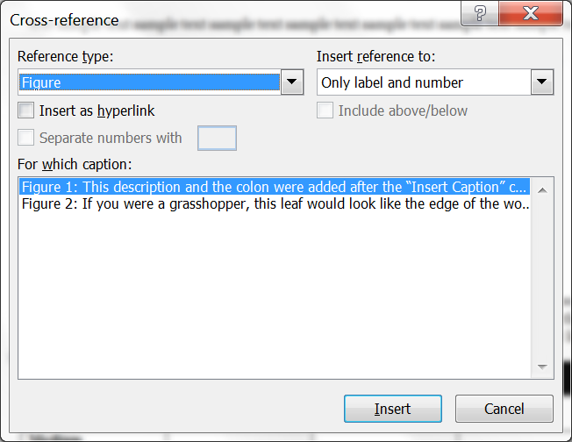
Figure 2-3: Cross-reference dialog box for referencing figures, tables, paragraphs, and other links within the narrative.

Troubleshooting Figure Captions
When you insert a figure, you may need to adjust its formatting. To view the borders of the table, click on the figure, click on the table, and then click on the “Layout” ribbon. (The “Layout” ribbon will not appear until you click on the figure or other content within the table). Then click on “View Gridlines.”
If the figure appears off-center, click on it, and make sure that the automatic paragraph indent is set to zero (Figure 2-4).
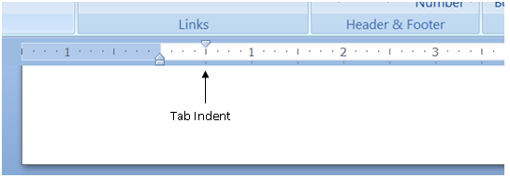
Figure 2-4: Indentation setting. To ensure that a figure is centered, the tab indent should be changed from ½ inch, as shown here, to 0 inches.

List of Figures
When you use the cross-reference method to label and cite your figures, word will be able to generate a List of Figures automatically. To update the List of Figures, go to the “List of Figures” (after the Table of Contents), right-click on the list, and select “Update field.” If you have added figures, you will need to select “Update entire table.” However, there is a formatting issue that requires some attention.
The Graduate School requires that when figure or table titles span more than one line in the list of figures, the page number must be to the right of the entire caption. For example, the List of Figures entry shown in Figure 2-5 is wrong because the word “should” is above the page number “8.” The right margin needs to be adjusted so that the text on the first line wraps to the second line, as in Figure 2-6.
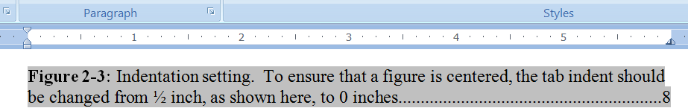
Figure 2-5: Incorrectly formatted List of Figures entry.
If your List of Figures and List of Tables entries do not appear as in Figure 2-6, you can modify them. The two tables are linked to the same format style, “Table of Figures.” To access this format, type the four keys <ctrl><alt><shift>S simultaneously. A list of styles will appear. Find the one labeled “Table of Figures,” and hover the cursor over it until a down-arrow appears on the right hand side. Click on the down-arrow and scroll to “Modify.” Click the “Format” button and scroll to “Paragraph.” In the paragraph dialogue box, change the value of “Right:” under “Indentation” from 0 to 0.25.
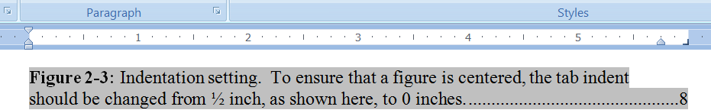
Figure 2-6: List of Figures entry, reformatted to conform to Graduate School requirements.
At times, you will need to update all field codes in your document, but will not want to update the list of figures because it has been formatted the way you wanted it. To freeze the table of contents, you can highlight it and use the two keys <ctrl><F11> together. You can unfreeze it later, if necessary, with <ctrl><shift><F11>.

Automated Tables

Creating Tables and Table Captions
A template for tables has also been provided in the “Quick Parts” gallery. On the “Insert” ribbon, select “Quick Parts” in the “Text” group, and scroll down to “A Table with Caption.” The template will appear as in Figure 2-7. The blue lines will appear only if you have selected “View Gridlines” under the “Layout” ribbon. (The Layout ribbon appears only when you place the cursor inside a table.)
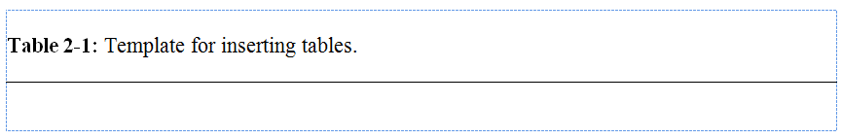
Figure 2-7: Template for inserting tables.
To generate a table, click in the cell below the black line of the template, go to the “Insert” ribbon, and click on the “Table” icon under the “Tables” group. Generate the table as appropriate.
If you have already generated data in Excel, you may wish to format it with Excel’s features and then copy it to the table template. When you do so, use “Paste Special” under the “Paste” icon in the “Clipboard” group of the “Home” ribbon, and select “Microsoft Office Excel Worksheet Object.” If, instead, you use “Paste as Nested Table,” “Paste Rows,” or simply “Paste,” the table will not be placed within the table template, and you will lose most of the advantages of the template.
Table 2-1 was generated with the table template and the “Table” icon on the “Insert” ribbon. The data were cut and pasted into the cells. To apply the formatting, the “Design” ribbon was selected, and the desired style was selected. If the row that contains the caption were generated as an additional row of the table, the application of this table style would have caused the caption row, instead of the top row of the table, to be black with white font.
Note that the decimal numbers in the last column of the table are aligned at the decimal point using a decimal tab, and not just centered in the column. This is the proper way to display decimal numbers, especially if they are not all of similar magnitudes.
Table 2-1: This table was generated with the table template and the “Table” icon on the “Insert” ribbon.
Specimen | E (N/m) | P_{max} (N) | $ρ$ (Kg/m³)
Long | 3 | 45 | 6.5
Medium | 4 | 44 | 14.5
Short | 2 | 44 | 115.7

Table Style
You are free to select the style you prefer for fonts and alignment within a table. However, a simple (minimalist) style is preferred in a formal document like a thesis/dissertation. See Table 2-2 for an example. This template provides a style named “Table Data” which adds 6 points of spacing above and below the table data and centers each data entry within its box.
Table 2-2: This is a minimalist table preferred for a formal document.
Specimen | E (N/m) | P_{max} (N) | $ρ$ (Kg/m³)
Long | 3 | 45 | 6.5
Medium | 4 | 44 | 14.5
Short | 2 | 44 | 115.7

Take care to ensure that your table description clearly identifies the table components and that your table headers include the units of each number. A good table should be understandable on its own. Do not force your reader to refer back to your narrative to determine the meaning of a given column or row.

References to Tables in the Narrative
To reference a table, such as Table 2-1, use a process similar to that used with figures. On the “References” ribbon, hit the “Cross-reference” button under the “Captions” group. Select “Table” and “Only Label and Number.”

Equations
Use the Microsoft Equation Editor to create equations. The editor for Word 2007 and later versions is substantially different from the editor for Word 2003. For more information, refer to the document on the equation editor by Jones (2010). Some comments on the problems that arise with numbered equations are included in APPENDIX B.

A Simple Way to Number Equations
This template provides a simple technique for generating numbered equations that can be cross-referenced in the narrative. On the “Insert” ribbon, in the “Symbols” group, click on the down-arrow under “Equation” (Figure 2-8). Scroll down to the box labeled “Numbered in Table” in the “A Thesis Template” category, and click on the box. The equation template, shown here as Eq. 2-1, will appear.
 | $$Type equation here.$$ | Eq. 2-1
Click on “Type equation here” and type in the equation you desire. As an example, Eq. 2-2 uses the template to create a second-order ordinary differential equation.
 | $$a\frac{d^{2}y}{dt^{2}}+b\frac{dy}{dt}+cy=f_{0}(t)$$ | Eq. 2-2
If the equation number is not correct after you insert the template, select the number component of the equation with the cursor, right-click, and scroll down to “Update Field.”
The use of a table allows the equation to be easily centered and circumvents certain limitations of Word’s equation numbering capabilities. You may wish to alter the shape of the table. To view the boundaries of the table and its cells easily, click on the table, go to the “Layout” ribbon, and click on “View Gridlines.”
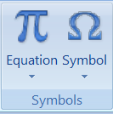
Figure 2-8: Symbols group, which can be used to insert equations from the equation gallery.

How to Cite Equations in the Narrative
To create a citation to an equation, place the cursor on the location within the text where the citation is to be created, and click on “Cross-reference” under the “References” ribbon. Select “Equation” in the “Reference Type” box, and click on the equation you wish to reference. To show the results of the entire process, Eq. 2-3 will be used to show Euler’s rule.
 | $$e^{iωt}=\cos\left(ωt\right)+i sin⁡(ωt)$$ | Eq. 2-3

Troubleshooting Equation Numbers
When you add new equations, you may need to update the equation numbers. You must first update the equation number in the label and then update the numbers in the citation(s). The citation will appear in the same format as the caption, so you may also need to reformat the reference if you wish it to appear in a different format.

METHODS

Reference Formatting
If you are using Mendeley or another bibliography management add-on, you can skip reading this chapter and get on with your writing. As you may find out from the Thesis/Dissertation workshop or the meta-course available online (contact Dr. Ramachandran: ramu@latech.edu if you need to get access), a bibliography management software is a highly recommended tool for making faster progress.

Reference Formatting and Referencing in Word
Bibliographical citations can be automated with the “Citations & Bibliography” group and the “Captions” group in the “References” ribbon. The examples provided here use the “Author name, Year” format for citation, which usually means that the References section is organized alphabetically by the last name of the first author. Note, however, that it is far more common in engineering and science disciplines to use a sequentially numbered style for referencing.
Getting on with our topic of using the Citation tools built into Word, assume, that you wished to reference (Jones, Leclerc, et al. 1996). First, click at the location where you wish the reference to be placed, and use the “Citations and Bibliography” group under the “References” ribbon to select a “Style.” Now use “Insert Citation,” and, if this is the first time that the reference is being used, scroll down to “Add New Source.” Fill in each field for the article that you are referencing. Multiple authors should be separated with a semicolon in the “Author” box. You may need to click on the box next to “Show all Bibliographical Fields” to type in some of the needed information. If you need to change a reference (e.g., you input the volume number incorrectly or misspelled an author’s name), you can do so with the “Manage Sources” button. When you finish typing the reference information and hit “OK,” a citation to that reference will appear at the location in your text, according to the Style you selected.
If you wish to cite a reference that has already been created, simply click on “Insert Citation” and scroll down to the reference you need. For example, the reference for the most excellent article on dissertation writing (Lopez, Watson and Fontana 2010) was already available when the citation on the previous line was inserted. Please note that a completely irrelevant photo is shown in Figure 3-1 so that the list of Figures will have more than just a couple of entries. Also note these irrelevant citations to (Hun 2010) (Pasluosta 2010).
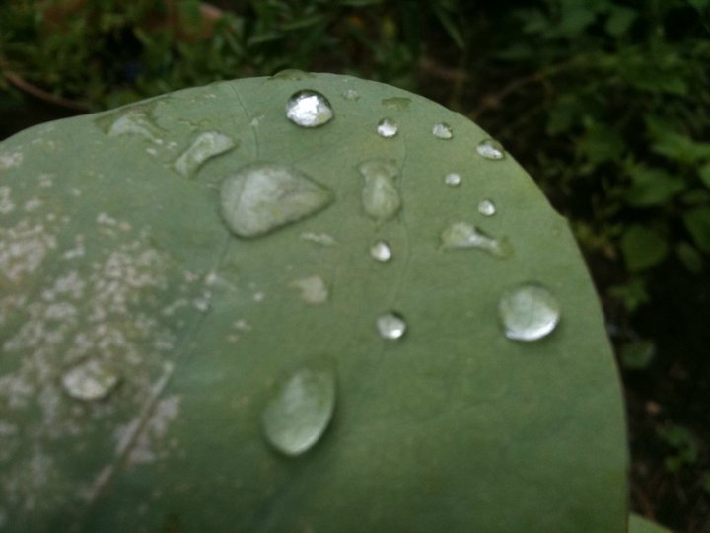
Figure 3-1: If you were a grasshopper, this leaf would look like the edge of the world.

References with Date Only
In some cases, you may wish to use the author’s name within your narrative. For example, you may want to say that Jones and Krishnamurthy (Reduction of Coherent Scattering Noise with Multiple Receiver Doppler 2002) demonstrated that Doppler ultrasound velocity measurements could be improved if multiple receivers were used. After you insert the citation, right-click on it, scroll down to “Edit Citation,” and click on the Suppress Author box. The citation will then include the date only.

Generating the Bibliography
To generate the bibliography at the end of your document, go to the location at which the bibliography is desired, and click on the down-arrow next to “Bibliography” in the Citations & Bibliography group of the References ribbon. Scroll down to “Bibliography,” and left-click. The bibliography will be created in the format you selected previously under the “Style” option in the Citations and Bibliography group. The style for the bibliography in this document is “Turabian.”

Additional Bibliographical Styles
It is likely that none of the twleve bibliography styles that are packaged with Word 2016 or 2019 (or Office 365) will be appropriate for your discipline, your advisor’s taste, and your own taste. Thirty-one free bibliography styles are available at the following web site (last accessed on August 17, 2023):
https://www.thefreewindows.com/21880/download-31-free-citation-bibliography-styles-microsoft-word/.
Microsoft also provides some tips on creating custom styles if you can tolerate a bit of XML coding:
https://learn.microsoft.com/en-us/office/vba/word/concepts/objects-properties-methods/create-custom-bibliography-styles
If your advisor and committee members need to update your bibliography during edits, they will also need to install the same reference style. Otherwise, you can lock the bibliography before you send it to your committee members by highlighting it and typing the two keys <ctrl><F11> together so that it will not change in response to <ctrl>A followed by <F9>.

RESULTS

Subheading One
The results that you obtain from this template will be amazing. There is little need to include this section of the template because you could just as easily add your own results section, if it did not already exist, simply by inserting a section/page break, typing the word “Results,” highlighting that word, clicking on the “Chapter Title” style, and then adding the two soft-returns between “CHAPTER 4” and “RESULTS,” as is nowhere described by Hun (The Book of Irrelevant Citations 2010), and Pasluosta (YEAH! 2010).

Subheading Two
Sample text sample text sample text sample text sample text sample text sample text sample text sample text sample text sample text sample text sample text sample text sample text sample text sample text sample text sample text sample text sample text sample text sample text sample text sample text sample text (Lopez, Watson and Fontana 2010).
Sample text sample text sample text sample text sample text sample text sample text sample text sample text sample text sample text sample text sample text sample text sample text sample text sample text sample text sample text sample text sample text sample text sample text sample text sample text sample text.
Sample text sample text sample text sample text sample text sample text sample text sample text sample text sample text sample text sample text sample text sample text and more sample text sample text sample text sample text sample text sample text sample text sample text sample text sample text sample text sample text.
A reference to an equation in a table is Eq. 4-1.
 | $$A=πr^{2}$$ | Eq. 4-1

DISCUSSION

We did not create any subsections in this chapter, but you are welcome to create subsections, sub-subsections and sub-sub-subsections as you wish. Sample text sample text sample text sample text sample text sample text sample text sample text sample text sample text sample text sample text sample text sample text sample text sample text sample text sample text sample text sample text sample text sample text sample text sample text sample text sample text. (Hun 2010) (Pasluosta 2010)
Sample text sample text sample text sample text sample text sample text sample text sample text sample text sample text sample text sample text sample text sample text sample text sample text sample text sample text sample text sample text sample text sample text sample text sample text sample text sample text (Lopez, Watson and Fontana 2010).
Sample text sample text sample text sample text sample text sample text sample text sample text sample text sample text sample text sample text sample text sample text sample text sample text sample text sample text sample text sample text sample text sample text sample text sample text sample text sample text. Sample text sample text sample text sample text sample text sample text sample text sample text sample text sample text sample text sample text sample text sample text sample text sample text sample text sample text sample text sample text sample text sample text sample text sample text sample text sample text.

CONCLUSIONS AND FUTURE WORK

Conclusions
Sample text sample text sample text sample text sample text sample text sample text sample text sample text sample text sample text sample text sample text sample text sample text sample text sample text sample text sample text sample text sample text sample text sample text sample text sample text sample text. (Hun 2010) (Pasluosta 2010).
Sample text sample text sample text sample text sample text sample text sample text sample text sample text sample text sample text sample text sample text sample text sample text sample text sample text sample text sample text sample text sample text sample text sample text sample text sample text sample text. (Lopez, Watson and Fontana 2010).
Sample text sample text sample text sample text sample text sample text sample text sample text sample text sample text sample text sample text sample text sample text sample text sample text sample text sample text sample text sample text sample text sample text sample text sample text sample text sample text.

Future Work
Sample text sample text sample text sample text sample text sample text sample text sample text sample text sample text sample text sample text sample text sample text sample text sample text sample text sample text sample text sample text sample text sample text sample text sample text sample text sample text.

- Purpose and format of an appendix

Appendices contain detailed material that may be of interest to some readers but would otherwise distract the reader from the main purpose of the document. Appendices are formatted similarly to chapters, but are sequenced with capital letters of the alphabet instead of numbers (e.g., “Appendix A” and “Appendix B” instead of “Chapter 1” and “Chapter 2”). Subsections of each appendix are labeled with that appendix’s identifying letter. Figures, tables and equations must also have the numbers that are preceded by the appendix letter.
  - Appendix Subsection
As with chapters, appendices can have subsections. This template provides up to six levels of sections for appendices, and their general format is as shown below.
    - Appendix Sub-Subsection
Appendix Sub-Sub-Subsection
Appendix Sub-Sub-Sub-Subsection
Appendix Sub-Sub-Sub-Sub-Subsection
  - Figures in Appendices
The numbering for figures in appendices must begin with the appendix label, such as “Figure A-1” in Appendix A, or “Figure B-1” in Appendix B. A figure template named “A Figure with Caption (Appendix)” is provided in the “Quick Parts” gallery that ensures correct labeling of figures in appendices. The template is shown in Figure A-1.
Figure A-1: Template for inserting figures into appendices.
Similarly, Table A-1 shows the table template, “A Table with Caption,” that should be used in appendices. The gray background is for clarity in this description and will not be present in your template.
Table A-1: Template for inserting tables in Appendices.

  - Equations in Appendices
In addition, an equation template is needed for appendices (Eq. A-1).
 | $$Type equation here.$$ | Eq. A-1

- Details about Captions

  - Figures
    - Standard Method for Generating Figure Captions
Captions can be generated without the need for a template from the “Quick Parts” gallery. After you insert a figure, right-click on it, scroll to “Insert Caption...,” and click. Then, in the box marked “Label,” select “Figure,” and then hit “OK.” The label “Figure” will appear below the figure, and you can add the caption text to that label (Figure B-2).

Figure B-2: A figure for which the caption was created with the “Insert Caption” command.
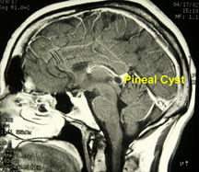

    - Problems with Standard Figure Captions
The caption appears to be fine, but some modifications were needed to make it appear as it does. The paragraph format for the caption was changed to remove 12 points of extra space above and below the text so that the caption would be double-spaced below the figure (instead of triple-spaced) and triple-spaced below the (instead of double-spaced), and so that the label “Figure B-2:” was reformatted to be bold. In addition, the field code that generates the text “Figure B-2” was modified so that the Appendix number (B) would appear instead of the number 6, which Word considers to be the current chapter number.
A more important issue is the behavior of the frame in which the caption is placed when additional text is added to before the figure (as will almost always occur during editing of a large document). When enough text has been added to push the figure to the next page, the frame remains at the bottom of the current page. You can see this behavior if you place your cursor just before the figure and insert new lines (Enter) until the figure is pushed to the next page.
The use of a table template to insert a figure, therefore, keeps the figure above the caption, provides a consistent format for all figure captions, and automatically provides the correct spacing (triple-spaced before the figure, double-spaced between the figure and the caption, and triple-spaced between the figure caption and the following text.
    - Details and Features of the Figure Template
To generate the figure template, a caption was first created for a figure in the standard manner. The frame for the caption was then deleted by right-clicking on it, scrolling to “format frame,” and then clicking on “remove frame.” The caption was then cut and pasted into the lower cell of a two-row, one-column table. The figure was copied and pasted into the upper cell. The upper cell was then formatted so that it would shrink/grow with the size of its contents, (right-click, “Table Properties,” “Table,” “Options,” “Automatically resize to fit contents…”), had zero left, right, and bottom cell margins, but a 0.17” top margin (right-click, “Table Properties,” “Cell,” “Options,” and set right and left cell margins to zero), and had no cell borders (right-click, “Table Properties,” “Table,” “Borders and Shading”). The 0.17” top margin is approximately 12 pt, which maintains the correct spacing between the table and the preceding text of the narrative. To adjust the other vertical spacing (between the figure and caption, and between the caption and ensuing text), the paragraph formatting of the upper cell was set to zero space before and after, and single-spaced text, and the paragraph formatting of the lower cell was set to 12 pt before, 24 pt after, and single-spaced text.
    - Disadvantages of the Table Method for Figures
In some cases, the paragraph formatting within the table will be in “Normal” style, with a leading indent. The indent causes the figure to be moved to the right 0.25 inches from the center. A second issue is that the 0.17 inch margin at the top of the figure is included even when the figure is at the top of the page. If you absolutely need this space, which is essentially ½ of a double-spaced line, you can remove the top margin. Right-click inside the cell, select “Table properties,” choose the “Table” tab, click on “Options,” and change “Top” from 0.17 to 0. In the vast majority of cases, this type of tweaking is something that should be reserved only for the more neurotic among us. Occasionally, however, you will want to fit certain material on a single page, and to do so you will need every millimeter of space that you can get.
Second-level headings are set to have an extra 12 points of space above them to provide a triple-space after the preceding paragraph. Whereas the 24 points of space after the figure caption provides the correct vertical spacing in most cases, it generates an extra 12 points of space when the figure is followed by a second-level heading. You may need to manually look through your document for cases in which a figure is immediately followed by a second-level heading and manually change the “space after” in the caption from 24 points to 12 points. A similar adjustment may be required for tables that are followed by second-level headings.
  - Tables
As with figure captions, table captions can be generated in a standard manner. First, create the table with ‘Insert | Table.” To use a built-in table format, double-click on the + at the upper-left corner of the table and select the style that you prefer. The standard method for adding captions to figures can be applied to tables. Right-click on the + at the upper-left corner of the table, and scroll down to “insert caption.” Select the label “Table,” and hit “OK.” Then modify the caption text as required. However, the same issues associated with frame boxes that apply to figures also apply to tables. To circumvent these issues, you can right-click on the frame box around the table caption and scroll down to “format frame.” Click on “remove frame,” and hit OK. Then create an extra row above the table, and cut and paste the table caption from the frame box to the extra row. It is easier, however, to use the built-in table template available in the Quick Parts gallery.
  - Comments on Equation Numbering in Microsoft Word
A number of features of Word conspire to make the numbering of equations awkward. For example, one can use the “Insert Captions” command on the References ribbon, but this command forces the numbering to appear above or below the equation, rather than to the right. The use of a table, as described Michaelstein (2006) solves many problems. We modified this approach such that the equation number is obtained from “Insert Caption” under the “References” ribbon instead of being created as a new multi-level list. If you attempt to insert a caption within the table cell in Microsoft Word, the caption will appear below the entire table instead of in the cell itself, but it can then be cut and pasted back into the cell.

REFERENCES

Hun, A T. The Book of Irrelevant Citations. Ruston: Psychodelic Publishing Company, 2010.
Jones, S A. "Equation Editor Shortcut Commands." Louisiana Tech Unversity, 2010: http://www2.latech.edu/~sajones/REU/Learning%20Exercises/Equation%20Editor%20Shortcut%20Commands.doc.
Jones, S A, and K Krishnamurthy. "Reduction of Coherent Scattering Noise with Multiple Receiver Doppler." Ultrasound in Medicine and Biology 28 (2002): 647-653.
Jones, S A, H Leclerc, G P Chatzimavroudis, Y H Kim, N A Scott, and A P Yoganathan. "The influence of acoustic impedance mismatch on post-stenotic pulsed-Doppler ultrasound measurements in a coronary artery model." Ultrasound in Medicine and Biology 22 (1996): 623-634.
Lopez, J M, M G. Watson, and J M Fontana. "Writing Dissertations in New Word Formats." LaTech Ph.D. Program (COES) 1, no. 1 (07 2010): 1-22.
Michaelstein, J. "Equation Editor." Microsoft Word 2010, The official blog of the Microsoft OfficeWord Product Team, 2006: http://blogs.msdn.com/b/microsoft_office_word/archive/2006/10/20/equation-numbering.aspx.
Pasluosta, C F. Getting My Ph.D. Done! 1. Vol. 1. 1 vols. Ruston, LA: Argentina Publications, 2010.

